

**### Part 1: Windows Server Attack**

**#### Question 1**

- Several users were impacted during the attack on March 25th.

- Based on the attack signatures, what mitigations would you recommend to protect each user account? Provide global mitigations that the whole company can use and individual mitigations that are specific to each user.

**Answer: -** With the help of Splunk website admin I found out the field key signature and value "an attempt was made to reset an accounts password" attacks happened between 8:00 am to 11:00am and peak took place at 9:00am and that time count was 1258.



**Global mitigations: -** There are few global mitigations based on the attack signatures, below are few mitigations.

* + Two factor authentication – it is an extra layer of protection used to ensure the security of online accounts beyond just a username and password.
  + Strong passwords consist of a combination of uppercase and lowercase letters, numbers and special symbols, such as punctuation.
  + The account lockout policy settings can be configured in the following location in the group policy management console.
  + Manage policies for force periodic password change
  + A rate-based rule tracks the rate limit from same source ip in firewall/ips of requests for each originating ip address, and triggers the rule action on IPS with rates that go over a limit.
  + Also, remote users should be allowed via secure VPN tunnel.

All of this would definitely reduce the number of successes attacks to access user accounts.

**Recommend individual mitigations to protect each user account: -** There are 3 account that need to look because of their count of hits were high on 25 march.

1. User _k logs showing several ‘an attempt was made to reset an account password’ and this account was attacked most of the time on 25 march, so the mitigation for user _k to set up alerts that send an email or txt to user with the lower & high number of attempt to change password and as well can block out all foreign ip addresses and only allowed known ip address.
2. User _a logs showing that ‘a user account was locked out’, at this time should send an alert to user and

User_a should immediately change the password with higher complexity. This is because the attacker is trying to brute force their way to the user’s password in order to steal the account.

3) user _ j logs showing that ‘an account was successfully logged on’ and in this scenario set up new login alert to send user and as well can set up two factor authentication and change manually the password if any alert come.

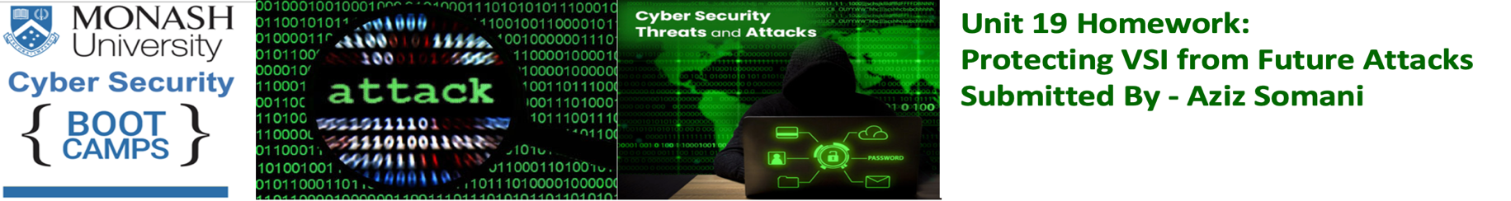





**#### Question 2**

- VSI has insider information that JobeCorp attempted to target users by sending "Bad Logins" to lock out every user.

- What sort of mitigation could you use to protect against this?

**Answer: -** The mitigation to protect user accounts from “Bad logins” could be allow login only from certain IP addresses and assign unique login URLs to blocks of other users, in this case other user cant access the site from the same URL also set up a group policy for the company that would automatically unlock users accounts after a specific amount of time bad logins and once the threshold will be over send an alert text or email to the user.

Also, I have mentioned Microsoft's 10/15/15 recommendation and with this rules windows account lockout can be configured with these three settings: -

**Account lockout threshold: -** the number of failed logon attempts that trigger account lockout. If set to 0, account lockout is disabled and accounts are never locked out.

**Account lockout duration: -** the number of minutes that an account remains locked out before it’s automatically unlocked. If set to 0, the account remains locked out until an administrator explicitly unlocks it.

**Reset account lockout counter after: -** the number of minutes after a failed logon attempt before the bad-logon counter is reset to 0. The counter is also reset after a successful logon.



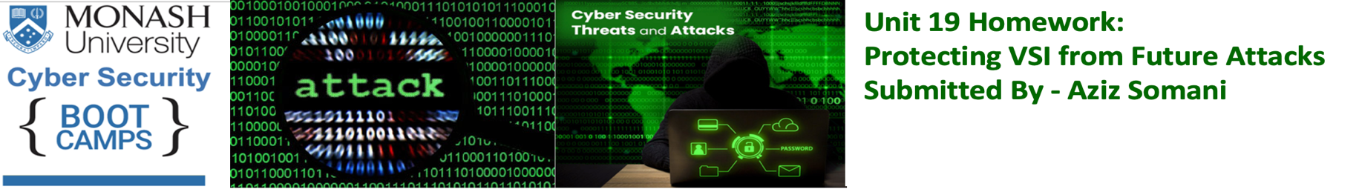

### Part 2: Apache Webserver Attack:

**#### Question 1**

- Based on the geographic map, recommend a firewall rule that the networking team should implement.

- Provide a "plain english" description of the rule.

- For example: "Block all incoming HTTP traffic where the source IP comes from the city of Los Angeles."

- Provide a screen shot of the geographic map that justifies why you created this rule.

**Answer: -** **Description of Firewall Rule: -** Block all incoming HTTP traffic where the source IP comes from the country Ukraine specially the city of Kiev.

The screen shot of the geographic map and its showing large number of incoming attacks were coming from Ukraine, therefore we should set up a firewall rule to block HTTP traffic from Ukraine.

 





**#### Question 2**

- VSI has insider information that JobeCorp will launch the same webserver attack but use a different IP each time in order to avoid being stopped by the rule you just created.

- What other rules can you create to protect VSI from attacks against your webserver?

- Conceive of two more rules in "plain english".

- Hint: Look for other fields that indicate the attacker.

**Answer: -** Below are the two rules and based on the user_agent and bytes, there was a user agent attacking by different IP address "Mozilla/4.0 (compatible; MSIE 6.0; Windows NT 5.2; SV1; .NET CLR 2.0.50727987787; InfoPath.1)" and recurring byte count was 65748.

* Block all traffic by default and explicitly enable only specific traffic to known the webserver services so basically whitelist all known IP Addresses in Network and this strategy provides good control over the traffic and reduces the possibility of a breach because of service misconfiguration.
* Block all incoming HTTP traffic where the useragent is "Mozilla/4.0 (compatible; MSIE 6.0; Windows NT 5.2; SV1; .NET CLR 2.0.50727987787; InfoPath.1) and also Block all incoming HTTP traffic where the bytes amount is 65748.







Thank you,

Aziz Somani